Introduction/Business Problem

I will use Data Collisions data set : Collisions—All Years and Analyse all incidents based on Accident time, Light condition and Block type.

Most of accidents was in 2006.

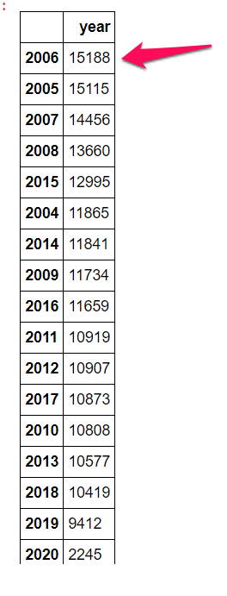

Most of accidents happened on Mid Block

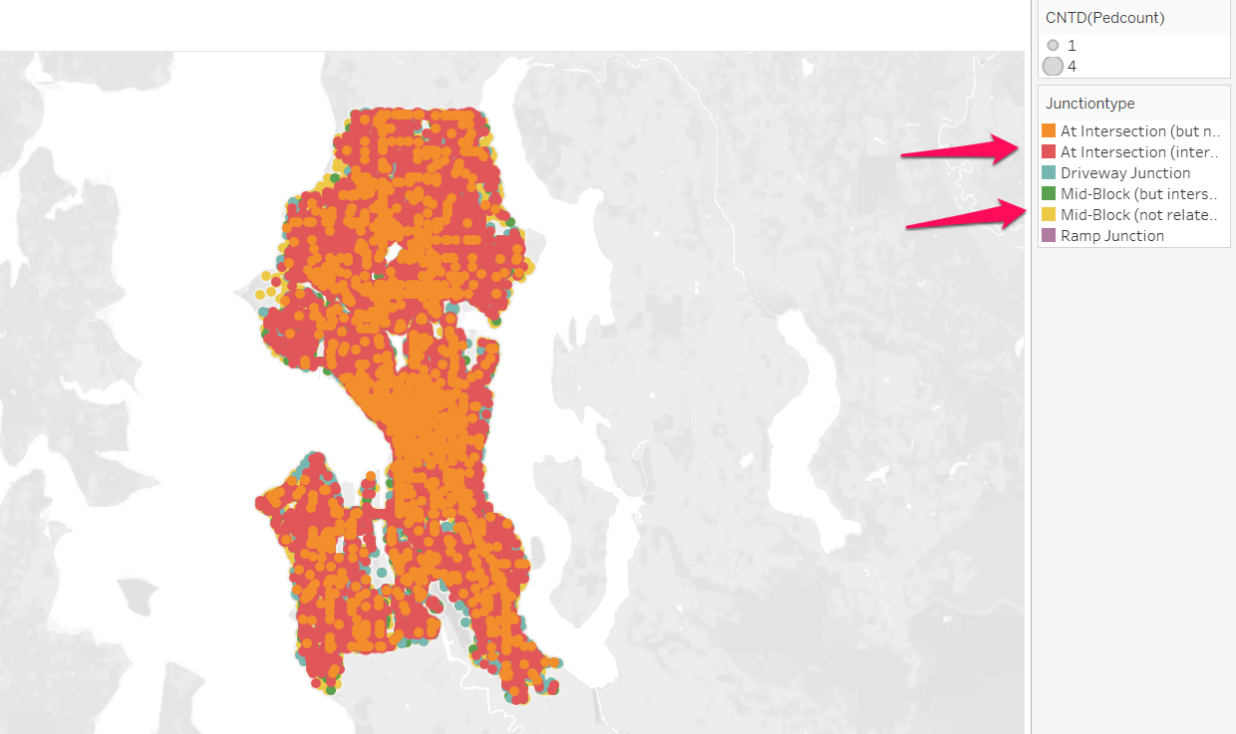

After analysing, it is clear that all accidents happened at midnight because poor street light

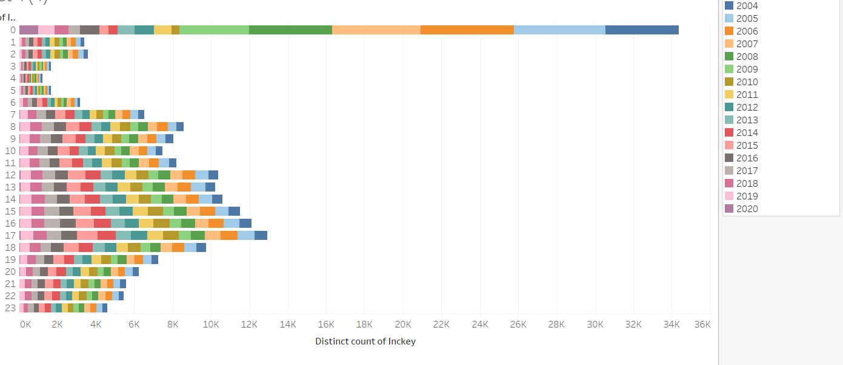

Most of accident Severity description is Property damage only

